ASSIGNMENT – 8

- Write a java program that will create the reference of the thread and display the details of the reference thread. (It should display class, name of thread, priority, group name)
Code:
class ThreadData extends Thread {
public void run() {
System.out.println("Class: "+getClass());
System.out.println("Name: "+getName());
System.out.println("Priority: "+getPriority());
System.out.println("Thread Group: "+getThreadGroup().getName());
}
}

class Q1 {
public static void main(String args[]) {
ThreadData t = new ThreadData();
t.start();
}
}
Output:
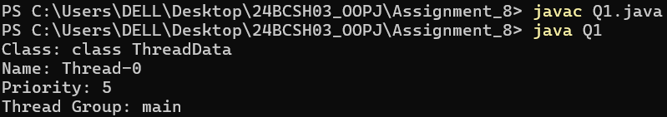
- Write a java program that will create a thread and set the thread name, display the thread name, get the thread id, check the thread is currently alive or not.
Code:
class MyThread extends Thread {
public void run() {
Thread t = Thread.currentThread();
System.out.println("The new name of the thread: "+t.getName());
System.out.println("Id: "+t.getId());
System.out.println("Is Alive: " +t.isAlive());
}
}

class Q2 {
public static void main(String args[]) {
MyThread t1 = new MyThread();
t1.setName("My Thread");
t1.start();
}
}
Ouput:
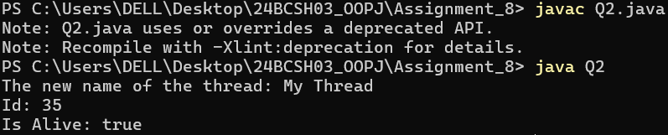
- Write a java program that will create one thread [using Runnable interface]. The main thread will read a number and the newly created thread checks the number is Armstrong number or not.
Code:
import java.util.*;
class ArmstrongCheck implements Runnable {
int n;
ArmstrongCheck(int n) {
this.n = n;
}
public void run() {
int temp = n;
int sum = 0, rem;
while (temp != 0) {
rem = temp % 10;
sum += rem * rem * rem;
temp /= 10;
}
if (sum == n)
System.out.println(n + " is an Armstrong number.");
else
System.out.println(n + " is not an Armstrong number.");
}
}
class Q3 {
public static void main(String[] args) {
Scanner sc = new Scanner(System.in);
System.out.print("Enter the number: ");
int n = sc.nextInt();
ArmstrongCheck a = new ArmstrongCheck(n);
Thread t = new Thread(a);
t.start();
}
}
Output:
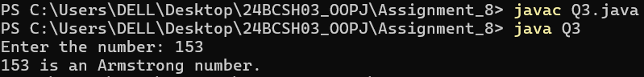
- Write a java program that will create one thread [using extends]. The main thread will read a number and check the number is prime or composite and the same time the new thread will check the number palindrome or not.
Code:
import java.util.Scanner;
class CheckPalindrome extends Thread {
int n;
CheckPalindrome(int n) {
this.n = n;
}
public void run() {
int temp = n;
int rem, rev = 0;
while (temp != 0) {
rem = temp % 10;
rev = rev*10 + rem;
temp = temp / 10;
}
if (rev == n)
System.out.println(n + " is a palindrome number.");
else
System.out.println(n + " is not a palindrome number.");
}
}
class Q4 {
public static void main(String[] args) {
Scanner sc = new Scanner(System.in);
System.out.print("Enter the number: ");
int n = sc.nextInt();
CheckPalindrome t = new CheckPalindrome(n);
t.start();
boolean isPrime = true;
if (n <= 1)
isPrime = false;
else {
for (int i = 2; i <= n / 2; i++) {
if (n % i == 0) {
isPrime = false;
break;
}
}
}
if (isPrime)
System.out.println(n + " is a prime number.");
else
System.out.println(n + " is not a prime number.");
}
}
Output:
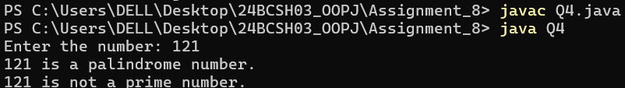
- Write a java program that will create one child thread. The child thread has to display all odd numbers between m and n, and the main thread will display all the even numbers between m and n.
Code:
import java.util.*;
class OddThread extends Thread {
private int m, n;
OddThread(int m, int n) {
this.m = m;
this.n = n;
}
public void run() {
System.out.print("Odd numbers: ");
for (int i = m; i <= n; i++) {
if (i % 2 != 0)
System.out.print(i + " ");
}
System.out.println();
}
}
class Q5 {
public static void main(String[] args) throws InterruptedException {
Scanner sc = new Scanner(System.in);
System.out.print("Enter m and n: ");
int m = sc.nextInt(), n = sc.nextInt();
OddThread t = new OddThread(m, n);
t.start();
t.join();
System.out.print("Even numbers: ");
for (int i = m; i <= n; i++) {
if (i % 2 == 0)
System.out.print(i + " ");
}
System.out.println();
sc.close();
}
}
Output:
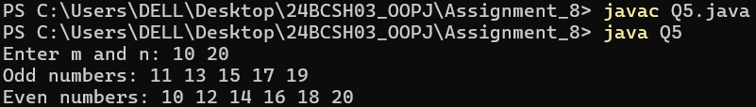
- Write a java program to create two threads. First thread should find the square of the number, second thread should find the sum of the digits of the number.
Code:
import java.util.Scanner;
class SquareThread extends Thread {
int num;
SquareThread(int n) {
num = n;
}
public void run() {
System.out.println("Square: " + (num * num));
}
}
class SumThread extends Thread {
int num;
SumThread(int n) {
num = n;
}
public void run() {
int sum = 0, temp = num;
while (temp != 0) {
sum += temp % 10;
temp /= 10;
}
System.out.println("Sum of the digits: " + sum);
}
}
class Q6 {
public static void main(String[] args) {
Scanner sc = new Scanner(System.in);
System.out.print("Enter the number: ");
int n = sc.nextInt();
SquareThread s1 = new SquareThread(n);
SumThread s2 = new SumThread(n);
s1.start();
s2.start();
}
}
Output:
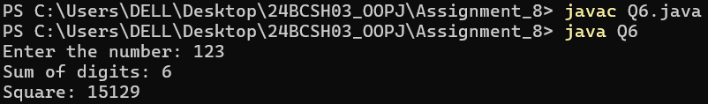
- Write a java program that will create two threads. The main thread will read a number and one thread will print the multiplication table of the entered number and the same time the other thread will find the factorial of the entered number. Note: Main thread has to wait until other two threads have completed their task.
Code:
import java.util.*;
class TableThread extends Thread {
int num;
TableThread(int n) {
num = n;
}
public void run() {
System.out.println("Multiplication Table");
for (int i = 1; i <= 10; i++) {
System.out.println(num + " x " + i + " = " + (num * i));
}
}
}
class FactorialThread extends Thread {
int num;
FactorialThread(int n) {
num = n;
}
public void run() {
int fact = 1;
for (int i = 1; i <= num; i++) {
fact *= i;
}
System.out.println("Factorial: " + fact);
}
}
class Q7 {
public static void main(String[] args) throws InterruptedException {
Scanner sc = new Scanner(System.in);
System.out.print("Enter a number: ");
int n = sc.nextInt();
TableThread t1 = new TableThread(n);
FactorialThread t2 = new FactorialThread(n);
t1.start();
t2.start();
}
}
Output:
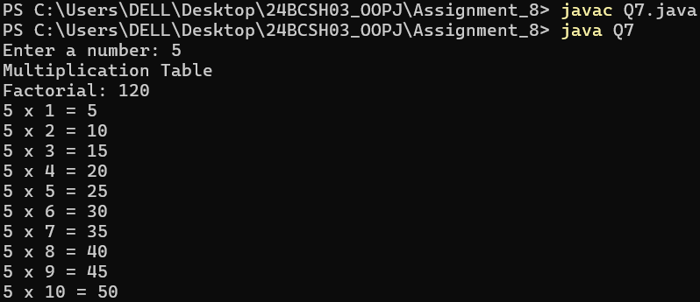
- Write a java program that will create two threads. Set the priority to each thread and display.
Code:
class Priority extends Thread {
public void run() {
System.out.println(getName() + " Priority: " + getPriority());
}
}
class Q8 {
public static void main(String[] args) {
Priority t1 = new Priority();
Priority t2 = new Priority();
t1.setPriority(2);
t2.setPriority(1);
t1.start();
t2.start();
}
}
Output:
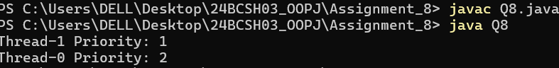
- Write a java program that will compute product of two 1D arrays using multithreading. The program should read two 1D arrays of same size from the user. First thread should multiply the corresponding elements present in the odd index position and second thread should multiply the corresponding elements present in the even index position. Main thread should display the result.
Code:
import java.util.Scanner;
class OddIndexProduct extends Thread {
int[] a, b, res;
OddIndexProduct(int[] a, int[] b, int[] res) {
this.a = a;
this.b = b;
this.res = res;
}
public void run() {
for (int i = 1; i < a.length; i += 2) {
res[i] = a[i] * b[i];
}
}
}
class EvenIndexProduct extends Thread {
int[] a, b, res;
EvenIndexProduct(int[] a, int[] b, int[] res) {
this.a = a;
this.b = b;
this.res = res;
}
public void run() {
for (int i = 0; i < a.length; i += 2) {
res[i] = a[i] * b[i];
}
}
}
class Q9 {
public static void main(String[] args) throws InterruptedException {
Scanner sc = new Scanner(System.in);
System.out.print("Enter size: ");
int n = sc.nextInt();
int[] a = new int[n];
int[] b = new int[n];
int[] res = new int[n];
System.out.println("Enter the elements of first array:");
for (int i = 0; i < n; i++) {
a[i] = sc.nextInt();
}
System.out.println("Enter the elements of second array:");
for (int i = 0; i < n; i++) {
b[i] = sc.nextInt();
}
OddIndexProduct t1 = new OddIndexProduct(a, b, res);
EvenIndexProduct t2 = new EvenIndexProduct(a, b, res);
t1.start();
t2.start();
t1.join();
t2.join();
System.out.println("Result array:");
for (int i : res) {
System.out.print(i + " ");
}
sc.close();
}
}
Output: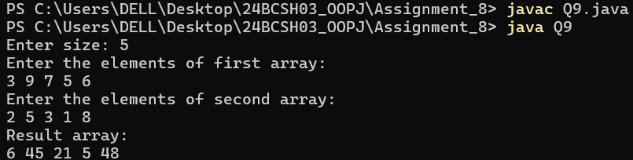
- Write a simple Java thread program to compute the sum of n natural numbers. The program should read the number of threads m and value of n from the user. Each of the threads should add its share of assigned number to a global variable. When all the threads are done, the global variable should contain the result. The program should use a Synchronized block to make sure that only one thread is updating the global variable at a given time.
Code:
import java.util.Scanner;
class SumThread extends Thread {
int start, end;
static int total = 0;
static final Object lock = new Object();
SumThread(int start, int end) {
this.start = start;
this.end = end;
}
public void run() {
int sum = 0;
System.out.println(getName() + " adding numbers from " + start + " to " + end);
for (int i = start; i <= end; i++) sum += i;
synchronized (lock) {
total += sum;
System.out.println(getName() + " finished. Partial sum = " + sum + ", Total = " + total);
}
}
}
public class Q10 {
public static void main(String[] args) throws InterruptedException {
Scanner sc = new Scanner(System.in);
System.out.print("Enter n: ");
int n = sc.nextInt();
System.out.print("Enter number of threads: ");
int m = sc.nextInt();
int part = n / m;
int start = 1;
for (int i = 0; i < m; i++) {
int end = (i == m - 1) ? n : (start + part - 1);
SumThread t = new SumThread(start, end);
t.setName("Thread-" + (i + 1));
t.start();
t.join(); // Wait for this thread to finish before starting the next
start = end + 1;
}
System.out.println("Final Sum of first " + n + " natural numbers = " + SumThread.total);
}
}
Output:
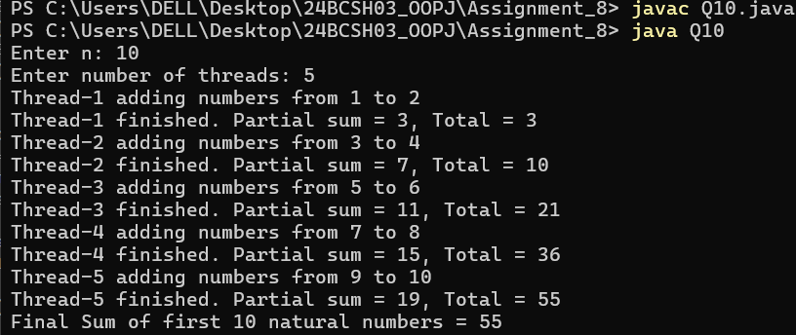
- Write a Java thread program to search the minimum number in a given array. The program should read the number of elements in the array, number of threads to be created and the array elements from the user. Each thread should find minimum element in an assigned block of elements and compare to global minimum element. When all the threads are done, the global variable should contain the minimum element. It should use a Synchronized block to make sure that only one thread is updating the global minimum variable at any given time.
Code:
import java.util.*;
class MinFinder extends Thread {
int[] arr;
int start, end;
static int globalMin = Integer.MAX_VALUE;
static final Object lock = new Object();
MinFinder(int[] arr, int start, int end) {
this.arr = arr;
this.start = start;
this.end = end;
}
public void run() {
int localMin = Integer.MAX_VALUE;
System.out.println(getName() + " checking from index " + start + " to " + end);
for (int i = start; i <= end; i++) {
if (arr[i] < localMin) localMin = arr[i];
}
synchronized (lock) {
if (localMin < globalMin) globalMin = localMin;
System.out.println(getName() + " finished. Local Min = " + localMin + ", Global Min = " + globalMin);
}
}
}
public class Q11 {
public static void main(String[] args) throws InterruptedException {
Scanner sc = new Scanner(System.in);
System.out.print("Enter number of elements: ");
int n = sc.nextInt();
int[] arr = new int[n];
System.out.println("Enter " + n + " elements:");
for (int i = 0; i < n; i++) arr[i] = sc.nextInt();
System.out.print("Enter number of threads: ");
int m = sc.nextInt();
int part = n / m;
int start = 0;
for (int i = 0; i < m; i++) {
int end = (i == m - 1) ? (n - 1) : (start + part - 1);
MinFinder t = new MinFinder(arr, start, end);
t.setName("Thread-" + (i + 1));
t.start();
t.join();
start = end + 1;
}
System.out.println("Minimum element in the array = " + MinFinder.globalMin);
}
}
Output:
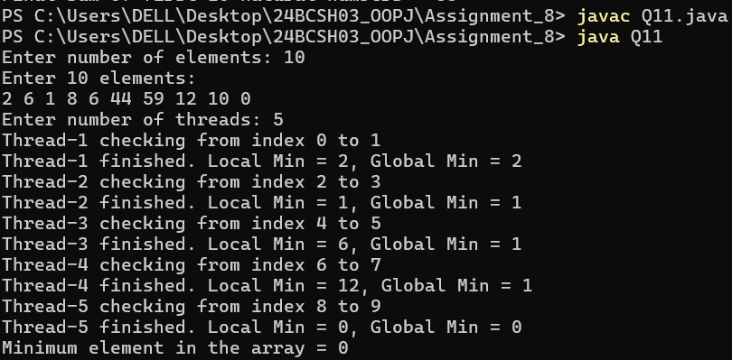
- Write a java program in which main thread should create two child threads (Producer and Consumer). First child thread (Producer) should produce ten random integers between 1 to 100 and the second child thread (Consumer) should check whether the generated number is even or odd. At the end the second child thread (Consumer) should print total number of even numbers received. Both the threads should wait and notify each other wherever necessary.
Code:
import java.util.Random;
class Shared {
int num;
boolean available = false;
}
class Producer extends Thread {
Shared s;
Random r = new Random();
Producer(Shared s) {
this.s = s;
}
public void run() {
for (int i = 1; i <= 10; i++) {
synchronized (s) {
while (s.available) {
try {
s.wait();
} catch (InterruptedException e) {
Thread.currentThread().interrupt();
}
}
s.num = r.nextInt(100) + 1;
System.out.println("Producer generated: " + s.num);
s.available = true;
s.notify();
}
}
}
}
class Consumer extends Thread {
Shared s;
int evenCount = 0;
Consumer(Shared s) {
this.s = s;
}
public void run() {
for (int i = 1; i <= 10; i++) {
synchronized (s) {
while (!s.available) {
try {
s.wait();
} catch (InterruptedException e) {
Thread.currentThread().interrupt();
}
}
System.out.println("Consumer received: " + s.num + " -> " +
(s.num % 2 == 0 ? "Even" : "Odd"));
if (s.num % 2 == 0) evenCount++;
s.available = false;
s.notify();
}
}
System.out.println("Total even numbers received by Consumer: " + evenCount);
}
}
public class Q12 {
public static void main(String[] args) {
Shared s = new Shared();
Producer p = new Producer(s);
Consumer c = new Consumer(s);
p.start();
c.start();
try {
p.join();
c.join();
} catch (InterruptedException e) {
Thread.currentThread().interrupt();
}
}
}
Output:
